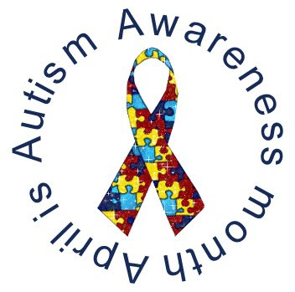In Honor of Autism Awareness Month

Redwood Coast Regional Center Dr. Lucille Esralew will present a training on social thinking for individuals on the Autism Spectrum
This presentation will unpack some of the key concepts linked with challenges for individuals on the autism spectrum including Theory of Mind (ToM), social communication and social reciprocity. The presenter will identify strategies that promote social thinking and social success for individuals on the autism spectrum at home, at school, at work and in the community.

Thursday, April 4th 9:30am-12:00pm
Redwood Coast Regional Center – Ukiah office large conf. Rm.
Video available at RCRC offices: Eureka, Lakeport, Crescent City & Fort Bragg
Please RSVP Alysia Barnes (707) 462-3832 EXT: 262

