::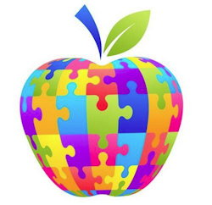;  - April 11. 2019  RCRC Parent AcaDEmy 11:30am-1:30pm -sequoia Rm.  Welcome to the first installment of our monthly meeting of the RCRC Parent Academy which will be open to parents of individuals with disabilities of all ages. In honor of Autism Awareness Month, Dr. Esralew will give a brief presentation on promoting social thinking and social success for individuals on the spectrum, followed by taking questions from parents regarding autism spectrum disorder.  Please RSVP: Alysia Barnes (707) 462-3832 Ext. 262 | Topics to be covered  ____  How to help your child’s academic success  ____  How to promote your child’s social effective  ____  How to help your child be as independent as possible  ____  REdwood Coast Regional Center  1116 Airport Park Blvd  Ukiah, CA  Video available at Lakeport, Eureka, Crescent City & Fort Bragg offices

