 | Redwood Coast Regional Center | 
 | Kimberly Smalley, Ph.D., Executive Director
 | 525 2nd Street, Ste 300, Eureka CA 95501
 | Phone: (707) 445-0893 • Fax: (707) 444-2563
 | E-mail: ksmalley@redwoodcoastrc.org
 | https://redwoodcoastrc.org
Summer 2024

Performance Report for Redwood Coast Regional Center

Every year, the Department of Developmental Services (DDS) contracts with regional centers in California to serve consumers and families. And, every year DDS looks at how well the regional centers are doing. This report will give you information about our regional center.

Last year, at Redwood Coast Regional Center (RCRC) we served about 4,760
clients. The charts on page three tell you about the clients we serve. You’ll also see how well we are doing in meeting our goals and in fulfilling our contract with DDS.

At RCRC, we want to improve every year, do better than the state average, and meet or exceed the DDS standard. As you can see in this report, we did well in all areas measured. We met or exceeded the state in average in most areas with one glaring exception, we still need to make significant improvement in our intake and assessment timelines for individuals age 3 or over.

In our catchment area of Del Norte, Humboldt, Lake and Mendocino Counties, almost all children live at home with their families, more adults live in home settings, no children live in settings with more than 6 people and very few adults live in settings with more than 6 people. RCRC has a board policy against institutionalization, in support of community-based supports. RCRC clients only live in developmental centers when court involvement dictates it.

We have met or exceeded all DDS standards with two exceptions; RCRC experienced a slight dip, from 98.3% to 97%, in meeting IPP requirements and we unfortunately experienced a significant drop from 83.55% to 59.3% in meeting intake and eligibility timelines for individuals over age 3. There are many barriers to meeting intake timelines, the most challenging of which is insufficient work force. RCRC has reorganized its intake dept., hired a new director of intake and eligibility to specifically address this area of need. We anticipate improvement in this area now that we have been able to recruit an additional eligibility assessor and fill open intake / eligibility coordinator positions.

The National Core Indicators Adult Family Survey data suggests that family members of adult clients served by RCRC are slightly less satisfied with their services, with an overall satisfaction of 69% than the state average of 74%: Our Native American respondents (25%); Hispanic/Latino respondents (60%) and White respondents (72%).

Overall, the respondents on the adult family survey did feel (81%) that services and supports have made a positive difference in the life of their adult family member with the state average at 79%: Our Native American respondent (0%) feeling the least satisfied, Hispanic/Latinos (80%) and white families (82%).

The most recent National Core Indicators Child family Survey asked, “Does your child have an Individual Family Plan (IPP) or Individual Family Service Plan (IFSP)?” Statewide only 58% of family members of children across the state, including those served by RCRC, reported that their child had an IPP or IFSP. Our Native American respondents (67%) Hispanic/Latino respondents (46%) and White respondents (65%).

Families of children reported that their IPP or IFSP included all the services and supports their child needed 60% of the time, slightly less than the state average of 63% of the time. Native American respondents (50%) Hispanic/Latinos respondents (69%) and White respondents (67%).

The National Core Indicators Adult Family Guardian Survey data suggests that overall family Guardians of clients served by RCRC are satisfied with the support received (75%). The state overall average was 78%. Our Native American respondents (33%) Hispanic/Latinos (50%) and White respondents (76%).

Family Guardians reported that their family member’s IPP or IFSP included all services and supports their family member needed 47% of the time, slightly less than the state average of 51%. Native American respondent (33%) Hispanic/Latino respondents (0%) and White respondents (49%).

RCRC has focused heavily on staff training and vendor recruitment this year in a concentrated effort to improve these experiences.

In the area of reducing disparities and improving equity for RCRC clients, Purchase of Service data suggests RCRC expenditures increased slightly across ethnicity groups between birth and age 21. Expenditures for adults remained essentially the same for adults across all ethnic groups except for white clients. Expenditures for White clients showed slight decreases between school age and adult clients. RCRC still needs to improve in the area of clients who receive case management services only, across age cohorts and ethnicity. Our highest number of clients receiving case management only being White clients between the ages of 3-21, followed by White adults aged 22 and older.

We hope this report helps you learn more about RCRC. If you have any questions or comments, please contact us!

This report is a summary. To see the complete report, go to: https://redwoodcoastrc.org/about-us/transparency-and-public-information/performance-reports/
Or contact Dr. Kimberly Smalley at 707-445-0893, x315 or by email at ksmalley@redwoodcoastrc.org.

Kimberly Smalley
Dr. Kimberly Smalley, Executive Director
Director, Redwood Coast Regional Center

Who uses RCRC?
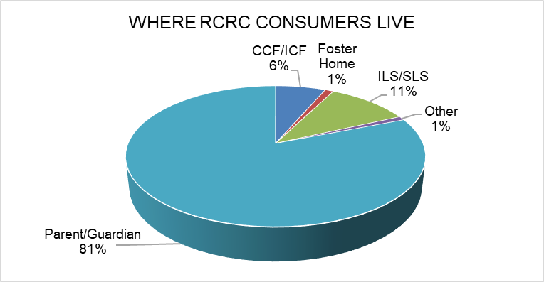
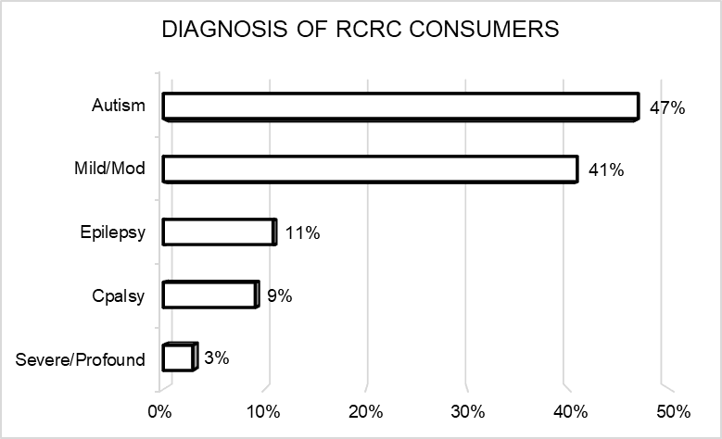
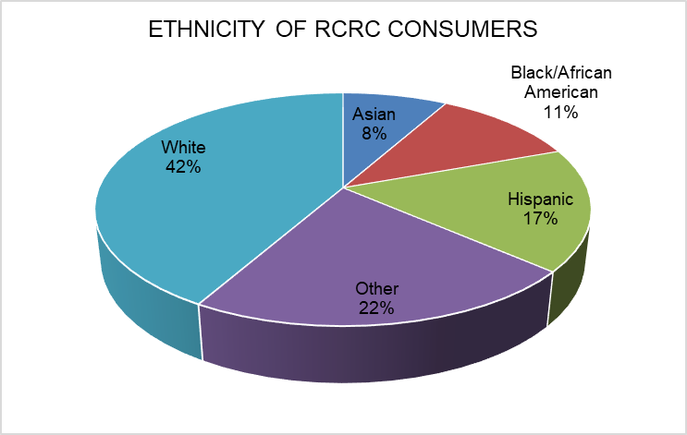
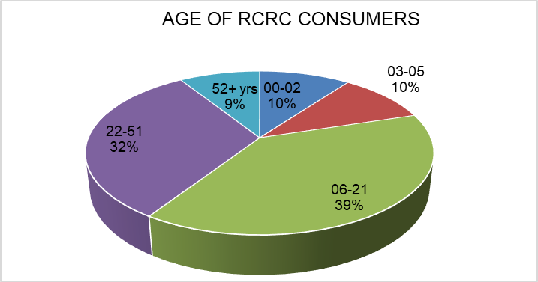
These charts tell you about who RCRC consumers are and where they live.

How well is RCRC performing?
This chart tells you five areas where DDS wants each regional center to keep improving.

The first column tells you how RCRC was doing last reporting period, and the second column shows how RCRC was doing at the end of fiscal year 2024.

To see how RCRC compares to the other regional centers in the state, compare the numbers to the state averages (in the shaded columns).
Regional Center Goals  (based on Lanterman Act) | Last Reporting Period  (December 2022) |  | Current Reporting Period  (June 2024)
Regional Center Goals  (based on Lanterman Act) | State Average | RCRC | State Average | RCRC
Fewer consumers live in developmental centers | 0.06% | 0.07% | 0.05% | 0.06%
More children live with families | 99.61% | 99.50% | 99.69% | 99.49%
More adults live in home settings | 83.01% | 93.01% | 83.86% | 93.27%
Fewer children live in large facilities (more than 6 people) | 0.03% | 0.05% | 0.02% | 0.00%
Fewer adults live in large facilities (more than 6 people) | 1.67% | 0.94% | 1.46% | 0.99%
Notes: 1) Consumers can be included in more than one diagnosis category. 2) Residence Types: CCF/ICF is Community Care Facility/Intermediate Care Facility; ILS/SLS is Independent Living Services/Supported Living Services. 3) Home settings include independent living, supported living, Adult Family Home Agency homes, and consumers’ family homes. 4) Green text indicates the RC remained the same or improved from the previous year, red indicates the RC did not improve.

Did RCRC meet DDS standards?
Read below to see how well RCRC did in meeting DDS compliance standards:
Areas Measured | Last Period | Current Period
Passes independent audit | Yes | Yes
Passes DDS audit | Yes | Yes
Audits vendors as required | Met | Met
Didn’t overspend operations budget | Yes | Yes
Participates in the federal waiver | Yes | Yes
CDERs and ESRs are updated as required (CDER is the Client Development Evaluation Report and ESR is the Early Start Report. Both contain information about consumers, including diagnosis.) | 92.14% | 99.72%
Intake/Assessment timelines for consumers age 3 or older met | 83.55% | 59.30%
IPP (Individual Program Plan) requirements met | 98.32% | 97.00%
IFSP (Individualized Family Service Plan) requirements met | 89.6% | 91.4%
Notes: 1) The federal waiver refers to the Medicaid Home and Community-Based Services Waiver program that allows California to offer services not otherwise available through the Medi-Cal program to serve people (including individuals with developmental disabilities) in their own homes and communities. 2) The CDER and ESR currency percentages were weighted based on the RC’s Status 1 and Status 2 caseloads to arrive at a composite score. 3) N/A indicates that the regional center was not reviewed for the measure during the current period.

In most areas RCRC met DDS standards. We passed our DDS and Independent audits, audited our vendors as required, and participated in the Medicaid Waiver. RCRC made great gains in keeping our CDERs and ESRs updated. We have struggled to meet intake/ assessment timelines for clients over age 3 this last year. Our growth exceeds the availability of eligibility assessors in our area. RCRC continues to actively recruit for a licensed Psychologist and additional contracted assessors who would be able to support Intake as we rapidly continue to grow.

How well is RCRC doing at getting consumers working?
The chart below shows how well RCRC is performing on increasing consumer employment performance compared to their prior performance and statewide averages:
Areas Measured |  | Time Period
 |  | CA | RCRC | CA | RCRC
Consumer Earned Income ( Age 16 to 64 years): |  | Jan through Dec 2022 |  | Jan through Dec 2023
Data Source: Employment Development Department
Quarterly number of consumers with earned income |  | 31,413 | 502 | 32,132 | 496
Percentage of consumers with earned income |  | 15.40% | 20.12% | 15.20% | 19.38%
Average annual wages |  | $13,198 | $9,063 | $14,251 | $10,063
Annual earnings of consumers compared to people with all disabilities in California |  | 2021 |  | 2022
Data Source: American Community Survey, 2022 five-year estimate |  | $30,783 |  | $29,382
National Core Indicator Adult In-Person Survey* |  | July 2017-June 2018 |  | July 2020-June 2021
Percentage of adults who reported having integrated employment as a goal in their IPP |  | 29% | 29% | 35% | N/A
Paid Internship Program |  | 2021-22 |  | 2022-23
Data Source: Paid Internship Program Survey |  | CA Average | RCRC | CA Average | RCRC
Number of adults who were placed in competitive, integrated employment following participation in a Paid Internship Program |  | 1,527 | 30 | 2,650 | 47
Percentage of adults who were placed in competitive, integrated employment following participation in a Paid Internship Program |  | 12% | 20% | 10% | 13%
Average hourly or salaried wages for adults who participated in a Paid Internship Program |  | $15.08 | $15.44 | $15.96 | $16.08
Average hours worked per week for adults who participated in a Paid Internship Program |  | 15 | 10 | 14 | 10
Competitive Integrated Employment
Data Source: Competitive Integrated Employment Incentive Program Survey
Average wages for adults engages in competitive, integrated employment, on behalf of whom incentive payments have been made |  | $15.63 | $15.06 | $16.51 | $16.71
Average hours worked for adults engages in competitive, integrated employment, on behalf of whom incentive payments have been made |  | 22 | 18 | 21 | 16
Total number of Incentive payments made for the fiscal year for the following amounts:** | $3,000 | 25 | 6 | 804 | 7
 | $2,500 | 42 | 13 | 849 | 12
 | $2,000 | 55 | 19 | 1,031 | 17
*Regional centers receive an 'N/A' designation within the table if fewer than 20 people responded to the survey item.

How well is RCRC doing at reducing disparities and improving equity?
These tables show you how well the regional center is doing at providing services equally for all consumers.

Percent of total annual purchase of service expenditures by individual’s ethnicity and age:

Age Group | Measure | American Indian or Alaska Native |  | Asian |  | Black/African American |  | Hispanic |  | Native Hawaiian or Other Pacific Islander |  | White |  | Other Ethnicity or Race
Age Group | Measure | 21-22 | 22-23 | 21-22 | 22-23 | 21-22 | 22-23 | 21-22 | 22-23 | 21-22 | 22-23 | 21-22 | 22-23 | 21-22 | 22-23
Birth to 2 | Consumers | 4% | 5% | 0% | 2% | 1% | 2% | 18% | 27% | 0% | 0% | 46% | 43% | 31% | 21%
Birth to 2 | Expenditures | 4% | 7% | 0% | 3% | 0% | 3% | 16% | 17% | 0% | 0% | 48% | 44% | 32% | 26%
3 to 21 | Consumers | 6% | 6% | 2% | 2% | 2% | 2% | 18% | 19% | 0% | 0% | 63% | 59% | 9% | 12%
3 to 21 | Expenditures | 6% | 5% | 2% | 2% | 1% | 1% | 15% | 17% | 1% | 1% | 65% | 63% | 10% | 11%
22 and older | Consumers | 5% | 5% | 1% | 1% | 2% | 2% | 8% | 9% | 0% | 0% | 81% | 79% | 3% | 5%
22 and older | Expenditures | 4% | 4% | 1% | 1% | 1% | 2% | 6% | 6% | 0% | 0% | 85% | 84% | 3% | 4%

Number and percent of individuals receiving only case management services by age and ethnicity:

Measure | Fiscal Year | Number of Eligible Consumers Receiving Case Management Only |  |  | Percent of Eligible Consumers Receiving Case Management Only
Measure | Fiscal Year | Birth to 2 | 3 to 21 | 22 and Older | Birth to 2 | 3 to 21 | 22 and Older
American Indian or Alaska Native | 21-22 | 3 | 64 | 13 | 10% | 53% | 14%
American Indian or Alaska Native | 22-23 | 6 | 57 | 9 | 15% | 41% | 9%
Asian | 21-22 | 1 | 17 | 1 | 33% | 43% | 5%
Asian | 22-23 | 2 | 18 | 1 | 13% | 41% | 4%
Black/African American | 21-22 | 0 | 9 | 6 | 0% | 25% | 13%
Black/African American | 22-23 | 3 | 9 | 1 | 19% | 23% | 2%
Hispanic | 21-22 | 9 | 78 | 22 | 7% | 20% | 13%
Hispanic | 22-23 | 33 | 76 | 21 | 15% | 17% | 11%
Native Hawaiian or Other Pacific Islander | 21-22 | 0 | 2 | 1 | N/A | 29% | 100%
Native Hawaiian or Other Pacific Islander | 22-23 | 0 | 5 | 1 | N/A | 45% | 100%
White | 21-22 | 36 | 421 | 135 | 11% | 31% | 8%
White | 22-23 | 51 | 400 | 146 | 14% | 29% | 9%
Other Ethnicity or Race | 21-22 | 13 | 77 | 10 | 6% | 43% | 14%
Other Ethnicity or Race | 22-23 | 19 | 76 | 11 | 11% | 27% | 11%
Total | 21-22 | 62 | 668 | 188 | 9% | 32% | 9%
Total | 22-23 | 114 | 641 | 190 | 14% | 27% | 9%

The tables below provide information on National Core Indicator survey results regarding services, satisfaction, and family outcomes, analyzed by race and ethnicity.

Overall, are you satisfied with the services and supports your family member currently receives?
(Response: Always/Usually, Adult Family Survey: 2021-22)
Ethnicity/Race | RCRC | All California Regional Centers
Total Number of Respondents | 160 | 8,302
Race Unknown | 33% | 64%
American Indian/Alaska Native | 25% | 79%
Asian | 100% | 73%
Black/African-American | N/A | 76%
Native Hawaiian/Pacific Islander | N/A | 66%
White | 72% | 74%
Other | 100% | 62%
Hispanic or Latino | 60% | 76%
Mixed Race | 70% | 73%
Overall | 69% | 74%
Do you feel that services and supports have made a positive difference in the life of your family member?
(Response: Yes, Adult Family Survey: 2021-22)
Ethnicity/Race | RCRC | All California Regional Centers
Total Number of Respondents | 160 | 8,302
Race Unknown | 100% | 73%
American Indian/Alaska Native | 0% | 82%
Asian | 100% | 76%
Black/African-American | N/A | 77%
Native Hawaiian/Pacific Islander | N/A | 69%
White | 82% | 82%
Other | 100% | 67%
Hispanic or Latino | 80% | 80%
Mixed Race | 81% | 80%
Overall | 81% | 79%

Does your child have an Individual Program Plan (IPP) or Individual Family Service Plan (IFSP)?
(Response: Yes, Child Family Survey: 2021-22)
Ethnicity/Race | RCRC | All California Regional Centers
Total Number of Respondents | 117 | 5,589
Race Unknown | 0% | 45%
American Indian/Alaska Native | 67% | 65%
Asian | 100% | 57%
Black/African-American | N/A | 63%
Native Hawaiian/Pacific Islander | N/A | 73%
White | 65% | 66%
Other | 67% | 52%
Hispanic or Latino | 46% | 53%
Mixed Race | 58% | 66%
Overall | 58% | 58%

Does the plan (IPP or IFSP) include all the services and supports your child needs?
(Response: Yes, Child Family Survey: 2021-22)
Ethnicity/Race | RCRC | All California Regional Centers
Total Number of Respondents | 68 | 3,239
Race Unknown | N/A | 66%
American Indian/Alaska Native | 50% | 69%
Asian | 100% | 62%
Black/African-American | N/A | 58%
Native Hawaiian/Pacific Islander | N/A | 91%
White | 67% | 55%
Other | 0% | 47%
Hispanic or Latino | 69% | 68%
Mixed Race | 36% | 60%
Overall | 60% | 63%

Overall, are you satisfied with the services and supports your family member currently receives?
(Response: Always/Usually, Family Guardian Survey: 2021-22)
Ethnicity/Race | RCRC | All California Regional Centers
Total Number of Respondents | 81 | 4,670
Race Unknown | 50% | 48%
American Indian/Alaska Native | 33% | 67%
Asian | 100% | 81%
Black/African-American | N/A | 72%
Native Hawaiian/Pacific Islander | N/A | 100%
White | 76% | 82%
Other | N/A | 79%
Hispanic or Latino | 50% | 73%
Mixed Race | 100% | 78%
Overall | 75% | 78%

Does your family member's plan (IPP or IFSP) include all the services and supports your family member needs?
(Response: Yes, Family Guardian Survey: 2021-22)
Ethnicity/Race | RCRC | All California Regional Centers
Total Number of Respondents | 81 | 4,670
Race Unknown | 50% | 33%
American Indian/Alaska Native | 33% | 44%
Asian | 0% | 53%
Black/African-American | N/A | 42%
Native Hawaiian/Pacific Islander | N/A | 0%
White | 49% | 54%
Other | N/A | 64%
Hispanic or Latino | 0% | 41%
Mixed Race | 50% | 50%
Overall | 47% | 51%

Notes
Asian category includes: Asian Indian, Cambodian, Chinese, Filipino, Hmong, Japanese, Korean, Laotian, Other Asian, Thai, and Vietnamese.
Native Hawaiian/Polynesian category includes Guamanian, Native Hawaiian, Other Pacific Islander, and Samoan.
White category includes Russian and White.
N/A means that there were no respondents for the category.
National Core Indicator survey responses reflect only the opinion of the regional center consumers that responded to the survey. For more details on the National Core Indicator survey, contact the regional center.

Want more information?
To see the complete report, go to: https://redwoodcoastrc.org/about-us/transparency-and-public-information/performance-reports/
Or contact Dr. Kimberly Smalley, Ph.D., BCBA-D
Executive Director, Redwood Coast Regional Center
at 707-445-0893, x315 or email at ksmalley@redwoodcoastrc.org

