 | Redwood Coast Regional Center  Jonathan Padilla, Interim Executive Director  1116 Airport Park Boulevard  Ukiah, CA 95482  Phone: 707-462-3832 x289  Email: JPadilla@RedwoodCoastRC.org | 

Summer 2025

Performance Report for Redwood Coast Regional Center

Every year, the Department of Developmental Services (DDS) contracts with regional centers in California to serve individuals and families. And, every year DDS looks at how well the regional centers are doing. This report will give you information about Redwood Coast Regional Center (RCRC).

Last year, RCRC served about 5,130 individuals. The charts on page two tell you about the individuals RCRC serves. You will also see how well RCRC is doing in meeting goals and in fulfilling our contract with DDS.

At RCRC, we want to improve every year, do better than the state average, and meet or exceed the DDS standard. As you can see from this report, we did well in almost all areas measured. We met or exceed the statewide average in most areas. We did make marginal improvements in one significant area, our intake and assessment timelines for individuals age three and over but still need to do much better in this area.

In Redwood Coast’s catchment area of Del Nort, Humboldt, Lake and Mendocino Counties, the majority (74%) reside with family. This is a decrease from the year before when 81% lived with family. This past year we saw a significant increase in clients accessing Independent Living Services/Supported Living Services (now 19% compared to 11% last year) and a decrease in reliance on Community Care Facilities and Intermediate Care Facilities (now 2% compared to 6% last year). RCRC significantly exceeds the statewide average for adults living in home-like settings and we have no children residing in facilities with more than six people. RCRC has a board policy against institutionalization, in support of community-based living. RCRC clients only live in developmental centers when court involvement dictates it.

We have met or exceeded all DDS standards with three exceptions; RCRC experienced a decrease in CDER and ESR’s being updated timely from 99.72% to 93.57%, Individual Program Plan/Individual Family Service Plan requirements being met decreased from 97% to 94.1%, and intake and assessment timelines saw a small increase in timeliness going from 59.3% to 61.68%. There are many barriers to meeting intake timelines, the most challenging of which is insufficient work force. RCRC has added a new Manager of Intake and Eligibility to specifically address this area of need. We anticipate improvement in this area now that we have also been able to recruit and fill open Intake Specialist positions.

The National Core Indicators Adult Family Survey 2021-2022 data suggests that family members of adult clients served by RCRC are slightly less satisfied with their services, with an overall satisfaction of 73% than the state average of 78%: White respondents (75%); Other (71%).

Overall, the respondents on the Adult Family Survey 2021-2022 did feel (84%) that services and supports have made a positive difference in the life of their adult family member with the state average at 84%: Hispanic/Latinos (80%) and white families (63%).

The most recent National Core Indicators Child Family Survey 2021-2022 asked, “Do you feel that services and supports have made a positive difference in the life of your child.” Statewide 81% of family members of children across the state, 83% overall for those served by RCRC, reported they felt the services made a positive difference in their life. Our Other respondents (76%) Hispanic/Latino respondents (89%) and White respondents (82%). Families of children also reported that their IPP or IFSP included all the services and supports their child needed 64% of the time, slightly less than the state average of 66% of the time.

The National Core Indicators Adult Family Guardian Survey 2021-2022 data suggests that overall family Guardians of clients served by RCRC are satisfied with the support received (80%). The state overall average was 84%. Family Guardians also reported that their family member’s IPP or IFSP included all services and supports their family member needed 73% of the time, slightly less than the state average of 77%.

RCRC has focused heavily on staff training and vendor recruitment this year in a concentrated effort to improve these experiences.

In the area of reducing disparities and improving equity for RCRC clients, Purchase of Service data suggests RCRC expenditures increased slightly across ethnicity groups between birth and age 21. The most notable changes were amongst our Hispanic clients/families. Expenditures for adults remained essentially the same for adults across all ethnic groups except for white clients. Expenditures for White clients showed increases for clients in their first two years of life and slight decreases between school age and adult clients. RCRC saw improvements for nearly every race/ethnicity category through reductions in the percentage of clients receiving only case management services. There is still work to do in reaching out and supporting clients/families access services and we continue to develop and support service access initiatives. Our highest number of clients only receiving case management services are White clients between the ages of 3-21, followed by White adults aged 22 and older.

We hope this report helps you learn more about RCRC. If you have any questions or comments, please contact us!

This report is a summary. To see the complete report, go to: https://redwoodcoastrc.org/about-us/transparency-and-public-information/performance-reports/
Or contact Jonathan Padilla at 707-462-3832 ext. 289 or by email at jpadilla@redwoodcoastrc.org.

Jonathan Padilla
Jonathan Padilla, Interim Executive Director
Redwood Coast Regional Center

Who uses RCRC?
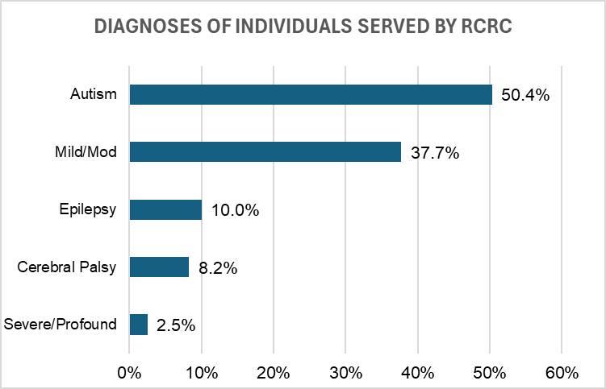
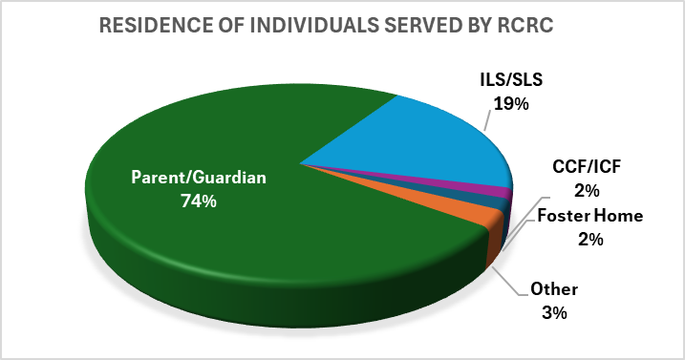
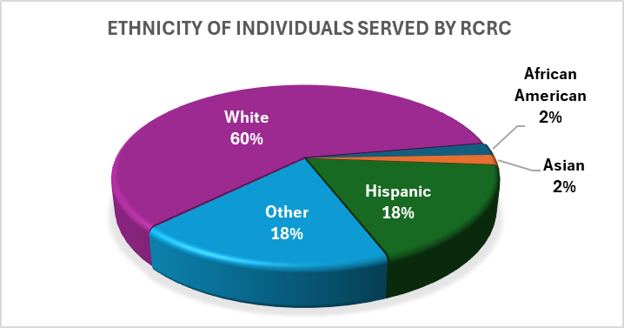
These charts tell you about who RCRC individuals are and where they live.

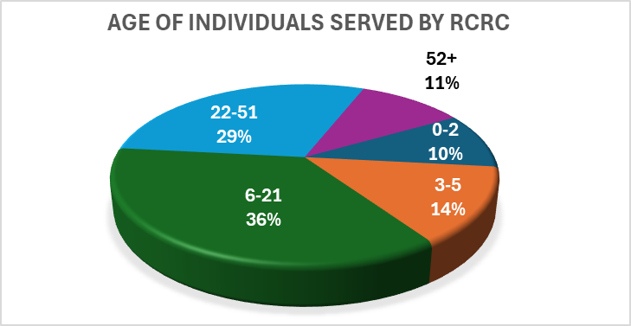
How well is RCRC performing?
This chart tells you five areas where DDS wants each regional center to keep improving.

The first column tells you how RCRC was doing last reporting period, and the second column shows how RCRC was doing at the end of fiscal year 2024-25.

To see how RCRC compares to the other regional centers in the state, compare the numbers to the state averages (in the shaded columns).
Regional Center Goals  (based on Lanterman Act) | June 2024 |  | June 2025
Regional Center Goals  (based on Lanterman Act) | State Average | RCRC | State Average | RCRC
More children live with families | 99.69% | 99.49% | 99.71% | 99.61%
More adults in home settings | 83.86% | 93.27% | 84.29% | 93.14%
Fewer children living in large facilities (more than 6 people) | 0.02% | 0.00% | 0.03% | 0.00%
Fewer adults live in large facilities (more than 6 people) | 1.46% | 0.99% | 1.36% | 0.55%
Notes: 1) Individuals can be included in more than one diagnosis category. 2) Residence Types: CCF/ICF is Community Care Facility/Intermediate Care Facility; ILS/SLS is Independent Living Services/Supported Living Services. 3) Home settings include independent living, supported living, Adult Family Home Agency homes, and individuals’ family homes. 4) Green text indicates the RC remained the same or improved from the previous year, red indicates the RC did not improve.

Did RCRC meet DDS standards?
Read below to see how well RCRC did in meeting DDS compliance standards:
Areas Measured | Last Reporting Period | Current Reporting Period
Passes independent audit | Yes | Yes
Passes DDS financial audit¹ | Yes | Yes
Audits vendors as required | Met | Met
Didn’t overspend operations budget | Yes | Yes
Participates in the federal waiver² | Yes | Yes
CDERs and ESRs are updated as required (CDER is the Client Development Evaluation Report and ESR is the Early Start Report. Both contain information about individuals, including diagnosis.)³ | 99.72% | 93.57%
Intake/Assessment timelines for individuals age 3 or older met | 59.30% | 61.68%
IPP (Individual Program Plan) requirements met | 97.00% | 94.10%
IFSP (Individualized Family Service Plan) requirements met | 91.4% | 92.3%
Notes: ¹ Link to DDS financial audit for fiscal years 2021-22 and 2022-23
² The federal waiver refers to the Medicaid Home and Community-Based Services Waiver program that allows California to offer services not otherwise available through the Medi-Cal program to serve people (including individuals with developmental disabilities) in their own homes and communities.
³ The CDER and ESR currency percentages are weighted based on the RC’s Status 1 and Status 2 June 2025 caseloads to arrive at a composite score.

In most areas RCRC met DDS standards. We passed our Independent Audits, audited our vendors as required, and participated in the Medicaid Waiver. RCRC saw a decrease in keeping our CDERs and ESRs updated. We have struggled to meet intake/assessment timelines for clients over age three this last year. Our growth exceeds the availability of eligibility assessors in our area. RCRC continues to actively recruit for a licensed Psychologist and additional contracted assessors who would be able to support our intake process as we rapidly continue to grow.

How well is RCRC doing at getting individuals working?
The chart below shows how well RCRC is performing on increasing individual employment performance compared to their prior performance and statewide averages:
Areas Measured |  | Time Period
 |  | CA | RCRC | CA | RCRC
Consumer Earned Income ( Age 16 to 64 years): |  | Jan through Dec 2023 |  | Jan through Dec 2024
Data Source: Employment Development Department
Quarterly number of consumers with earned income |  | 32,132 | 496 | 32,936 | 541
Percentage of consumers with earned income |  | 15.20% | 19.38% | 15.60% | 20.64%
Average annual wages |  | $14,251 | $10,063 | $14,902 | $10,702
Annual earnings of consumers compared to people with all disabilities in California |  | 2022 |  | 2023
Data Source: American Community Survey, 2022 five-year estimate |  | $29,382 |  | $31,436
Paid Internship Program |  | 2022-23 |  | 2023-24
Data Source: Paid Internship Program Survey |  | CA Average | RCRC | CA Average | RCRC
Number of adults who were placed in competitive, integrated employment following participation in a Paid Internship Program |  | 12 | 6 | 13 | 7
Percentage of adults who were placed in competitive, integrated employment following participation in a Paid Internship Program |  | 10% | 13% | 9% | 10%
Average hourly or salaried wages for adults who participated in a Paid Internship Program |  | $15.96 | $16.08 | $16.74 | $16.41
Average hours worked per week for adults who participated in a Paid Internship Program |  | 14 | 10 | 14 | 11
Competitive Integrated Employment
Data Source: Competitive Integrated Employment Incentive Program Survey
Average wages for adults engaged in competitive, integrated employment, on behalf of whom incentive payments have been made |  | $16.51 | $16.71 | $17.33 | $16.65
Average hours worked for adults engages in competitive, integrated employment, on behalf of whom incentive payments have been made |  | 21 | 16 | 21 | 13
Total number of Incentive payments made for the fiscal year for the following amounts: | $3,000 | 38 | 7 | 35 | 3
 | $2,500 | 40 | 12 | 40 | 2
 | $2,000 | 49 | 17 | 51 | 0
Notes: 1) The National Core Indicator Survey question "Percentage of Adults who Reported having integrated employment as a goal on their IPP" is no longer asked and therefore could not be included on the report. 2) Differences in regional center population sizes may affect the number of individuals participating in employment programs.

How well is RCRC doing at reducing disparities and improving equity?
These tables show you how well the regional center is doing at providing services equally for all individuals.

Percent of total annual purchase of service expenditures by individual’s ethnicity and age

Age Group | Measure | American Indian or Alaska Native |  | Asian |  | Black/African American |  | Hispanic |  | Native Hawaiian or Other Pacific Islander |  | White |  | Other Ethnicity or Race
Age Group | Measure | 22-23 | 23-24 | 22-23 | 23-24 | 22-23 | 23-24 | 22-23 | 23-24 | 22-23 | 23-24 | 22-23 | 23-24 | 22-23 | 23-24
Birth to 2 | Individuals | 5% | 6% | 2% | 2% | 2% | 1% | 27% | 30% | 0% | 0% | 43% | 48% | 21% | 14%
Birth to 2 | Expenditures | 7% | 6% | 3% | 3% | 3% | 1% | 17% | 22% | 0% | 0% | 44% | 57% | 26% | 11%
3 to 21 | Individuals | 6% | 6% | 2% | 2% | 2% | 2% | 19% | 22% | 0% | 0% | 59% | 56% | 12% | 11%
3 to 21 | Expenditures | 5% | 6% | 2% | 2% | 1% | 1% | 17% | 18% | 1% | 1% | 63% | 61% | 11% | 10%
22 and older | Individuals | 5% | 5% | 1% | 1% | 2% | 2% | 9% | 9% | 0% | 0% | 79% | 79% | 5% | 4%
22 and older | Expenditures | 4% | 5% | 1% | 1% | 2% | 2% | 6% | 7% | 0% | 0% | 84% | 82% | 4% | 3%

Number and percent of individuals receiving only case management services by age and ethnicity
Measure | Year | Number of Eligible individuals Receiving Case Management Only |  |  | Percent of Eligible individuals Receiving Case Management Only
Measure | Year | Birth to 2 | 3 to 21 | 22 and Older | Birth to 2 | 3 to 21 | 22 and Older
American Indian or Alaska Native | 22-23 | * | 57 | * | * | 41% | *
American Indian or Alaska Native | 23-24 | * | 45 | * | * | 28% | *
Asian | 22-23 | * | 18 | * | 13% | 41% | 4%
Asian | 23-24 | * | 20 | * | 11% | 34% | 7%
Black/African American | 22-23 | * | * | * | 19% | * | *
Black/African American | 23-24 | 0 | * | * | 0% | * | *
Hispanic | 22-23 | 33 | 76 | 21 | 15% | 17% | 11%
Hispanic | 23-24 | 36 | 78 | 14 | 15% | 13% | 7%
Native Hawaiian or Other Pacific Islander | 22-23 | 0 | 5 | * | N/A | 45% | 100%
Native Hawaiian or Other Pacific Islander | 23-24 | 0 | * | 0 | N/A | * | 0%
White | 22-23 | 51 | 400 | 146 | 14% | 29% | 9%
White | 23-24 | 27 | 334 | 123 | 7% | 23% | 7%
Other Ethnicity or Race | 22-23 | 19 | 76 | ** | 11% | 27% | **
Other Ethnicity or Race | 23-24 | * | 77 | ** | * | 26% | **
Total | 22-23 | 114 | 641 | 190 | 14% | 27% | 9%
Total | 23-24 | 73 | 564 | 167 | 9% | 21% | 8%

* In accordance with California Health and Human Services de-identification guidelines, counts of one through ten have been suppressed.
** In accordance with California Health and Human Services de-identification guidelines, complementary cells have been suppressed.

The tables below provide information on National Core Indicator (NCI) survey results regarding services, satisfaction, and family outcomes, analyzed by race and ethnicity.

Overall, are you satisfied with the services and supports your family currently receives?
(Response: Always/Usually, Adult Family Survey 2021-2022)
Race/Ethnicity¹ | RCRC^{2,3} | All California Regional Centers^{2,3}
Total Number of Respondents | 148 | 7,259
American Indian/Alaska Native | N/A | 81%
Asian | N/A | 77%
Black/African-American | N/A | 82%
Native Hawaiian/Pacific Islander | N/A | 74%
White | 75% | 77%
Other | 71% | 75%
Hispanic or Latino | N/A | 80%
Overall | 73% | 78%
Does the plan include all the services and supports your family member needs?
(Response: Yes, Adult Family Survey 2021-2022)
Race/Ethnicity¹ | RCRC^{2,3} | All California Regional Centers^{2,3}
Total Number of Respondents | 98 | 4,628
American Indian/Alaska Native | N/A | 79%
Asian | N/A | 76%
Black/African-American | N/A | 72%
Native Hawaiian/Pacific Islander | N/A | 64%
White | 59% | 67%
Other | 71% | 69%
Hispanic or Latino | N/A | 78%
Overall | 62% | 72%
Do you feel that services and supports have made a positive difference in the life of your family member?
(Response: Yes, Adult Family Survey 2021-2022)
Race/Ethnicity¹ | RCRC^{2,3} | All California Regional Centers^{2,3}
Total Number of Respondents | 147 | 7254
American Indian/Alaska Native | N/A | 84%
Asian | N/A | 80%
Black/African-American | N/A | 83%
Native Hawaiian/Pacific Islander | N/A | 83%
White | 87% | 86%
Other | 82% | 82%
Hispanic or Latino | 80% | 85%
Overall | 84% | 84%

Overall, are you satisfied with the services and supports your child currently receives?
(Response: Always/Usually, Child Family Survey 2021-2022)
Race/Ethnicity¹ | RCRC^{2,3} | All California Regional Centers^{2,3}
Total Number of Respondents | 112 | 5,100
American Indian/Alaska Native | N/A | 84%
Asian | N/A | 67%
Black/African-American | N/A | 73%
Native Hawaiian/Pacific Islander | N/A | 93%
White | 63% | 64%
Other | 62% | 70%
Hispanic or Latino | 80% | 68%
Overall | 68% | 68%
Does the plan include all the services and supports your child needs?
(Response: Yes, Child Family Survey 2021-2022)
Race/Ethnicity¹ | RCRC^{2,3} | All California Regional Centers^{2,3}
Total Number of Respondents | 64 | 2,974
American Indian/Alaska Native | N/A | N/A
Asian | N/A | 66%
Black/African-American | N/A | 64%
Native Hawaiian/Pacific Islander | N/A | N/A
White | 69% | 56%
Other | N/A | 60%
Hispanic or Latino | N/A | 73%
Overall | 64% | 66%
Do you feel that services and supports have made a positive difference in the life of your child?
(Response: Yes, Child Family Survey 2021-2022)
Race/Ethnicity¹ | RCRC^{2,3} | All California Regional Centers^{2,3}
Total Number of Respondents | 112 | 5,073
American Indian/Alaska Native | N/A | 90%
Asian | N/A | 79%
Black/African-American | N/A | 78%
Native Hawaiian/Pacific Islander | N/A | 93%
White | 82% | 83%
Other | 76% | 80%
Hispanic or Latino | 89% | 80%
Overall | 83% | 81%

Overall, are you satisfied with the services and supports your family currently receives?
(Response: Always/Usually, Family Guardian Survey 2021-2022)
Race/Ethnicity¹ | RCRC^{2,3} | All California Regional Centers^{2,3}
Total Number of Respondents | 75 | 4,171
American Indian/Alaska Native | N/A | 71%
Asian | N/A | 88%
Black/African-American | N/A | 76%
Native Hawaiian/Pacific Islander | N/A | N/A
White | 81% | 86%
Other | N/A | 81%
Hispanic or Latino | N/A | 80%
Overall | 80% | 84%
Does the plan include all the services and supports your family member needs?
(Response: Yes, Family Guardian Survey 2021-2022)
Race/Ethnicity¹ | RCRC^{2,3} | All California Regional Centers^{2,3}
Total Number of Respondents | 51 | 2,971
American Indian/Alaska Native | N/A | 76%
Asian | N/A | 83%
Black/African-American | N/A | 74%
Native Hawaiian/Pacific Islander | N/A | N/A
White | 73% | 77%
Other | N/A | 69%
Hispanic or Latino | N/A | 81%
Overall | 73% | 77%
Do you feel that services and supports have made a positive difference in the life of your family member?
(Response: Yes, Family Guardian Survey 2021-2022)
Race/Ethnicity¹ | RCRC^{2,3} | All California Regional Centers^{2,3}
Total Number of Respondents | 74 | 4,175
American Indian/Alaska Native | N/A | 73%
Asian | N/A | 88%
Black/African-American | N/A | 83%
Native Hawaiian/Pacific Islander | N/A | N/A
White | 86% | 90%
Other | N/A | 86%
Hispanic or Latino | N/A | 86%
Overall | 85% | 88%

Notes on NCI Data: 1. Race/Ethnicity information was recoded into seven (7) mutually exclusive categories: American Indian/Alaska Native, Asian, Black/African American, Hawaiian/Pacific Islander, Hispanic/Latino, White, Other. Asian category included Asian Indian, Chinese, Filipino, Japanese, Korean, Vietnamese, Middle Eastern, Other Asian. Hawaiian/Pacific Islander category included Native Hawaiian, Guamanian or Chamorro, Samoan, or Other Pacific Islander. Hispanic/Latino category included Mexican, Mexican-American, Chicano, Puerto Rican, Cuban, or Other Spanish/Hispanic/Latino. White category included European, Eastern European, and Russian. Other includes Mixed Race category of individuals who selected more than one racial/ethnic category and those who selected Other for their race. 2. Response option "Does Not Apply", and missing responses are excluded from the percentage calculation. 3. To protect confidentiality, cell sizes with 11 or fewer individuals have been suppressed with a notation of N/A, in accordance with Department of Health Care Services data de-identification guidelines. 4. Race/Ethnicity categories have been revised to align with state and national reporting.

Want more information?
To see the complete report, go to: https://redwoodcoastrc.org/about-us/transparency-and-public-information/performance-reports/
Or contact Jonathan Padilla, Interim Executive Director at 707-462-3832 ext 289 or by email at jpadilla@redwoodcoastrc.org.
Additional information can be found on the: DDS Regional Center Dashboard

